CSCE 560

2nd Lt David Crow

Wireshark Lab 3

1. What is the IP address and TCP port number used by the client computer (source) that is transferring the file to gaia.cs.umass.edu? To answer this question, it’s probably easiest to select an HTTP message and explore the details of the TCP packet used to carry this HTTP message, using the “details of the selected packet header window” (refer to Figure 2 in the “Getting Started with Wireshark” Lab if you’re uncertain about the Wireshark windows).

The source’s IP address is 192.168.1.102. The source’s port number is 1161.

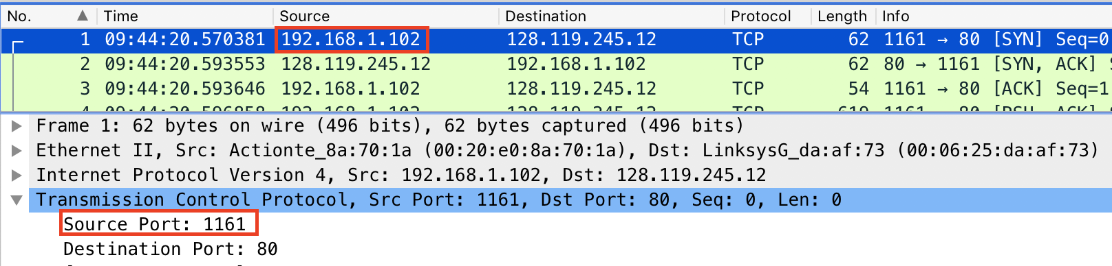

1. What is the IP address of gaia.cs.umass.edu? On what port number is it sending and receiving TCP segments for this connection?

The IP address is 128.119.245.12. It sends and receives segments on port 80.

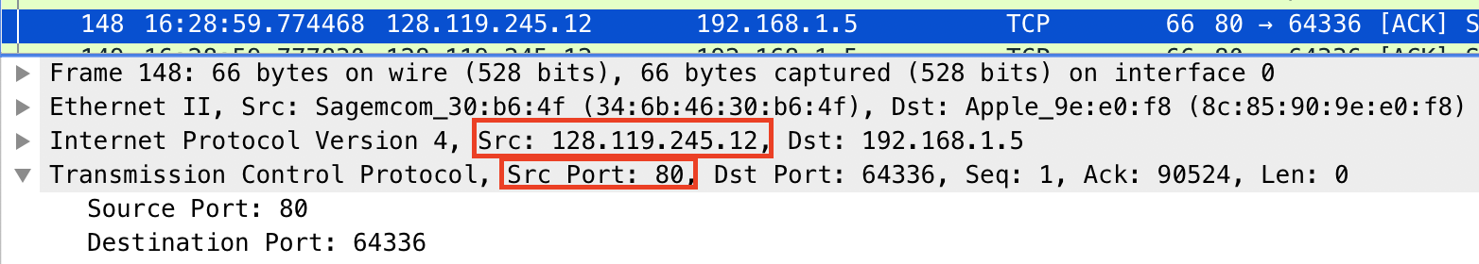

1. What is the IP address and TCP port number used by your client computer (source) to transfer the file to gaia.cs.umass.edu?

The source’s IP address is 192.168.1.5. The source’s port number is 65283.

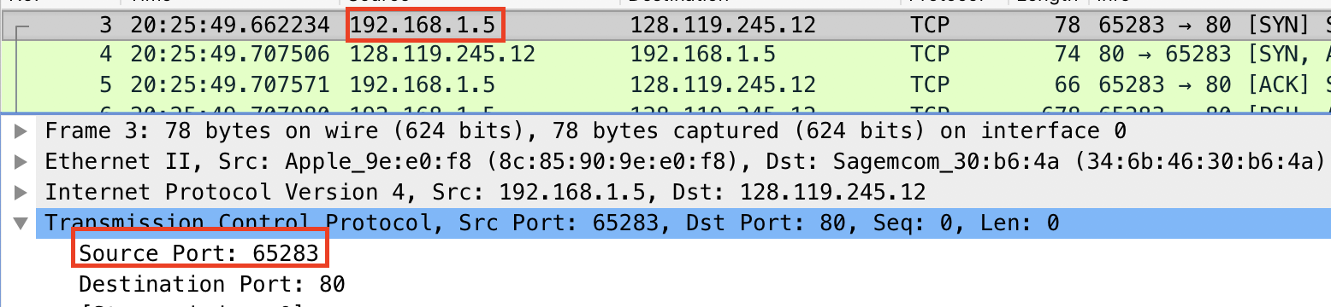

1. What is the sequence number of the TCP SYN segment that is used to initiate the TCP connection between the client computer and gaia.cs.umass.edu? What is it in the segment that identifies the segment as a SYN segment?

The sequence number is 0. The syn flag is set, so we know we have a SYN segment.

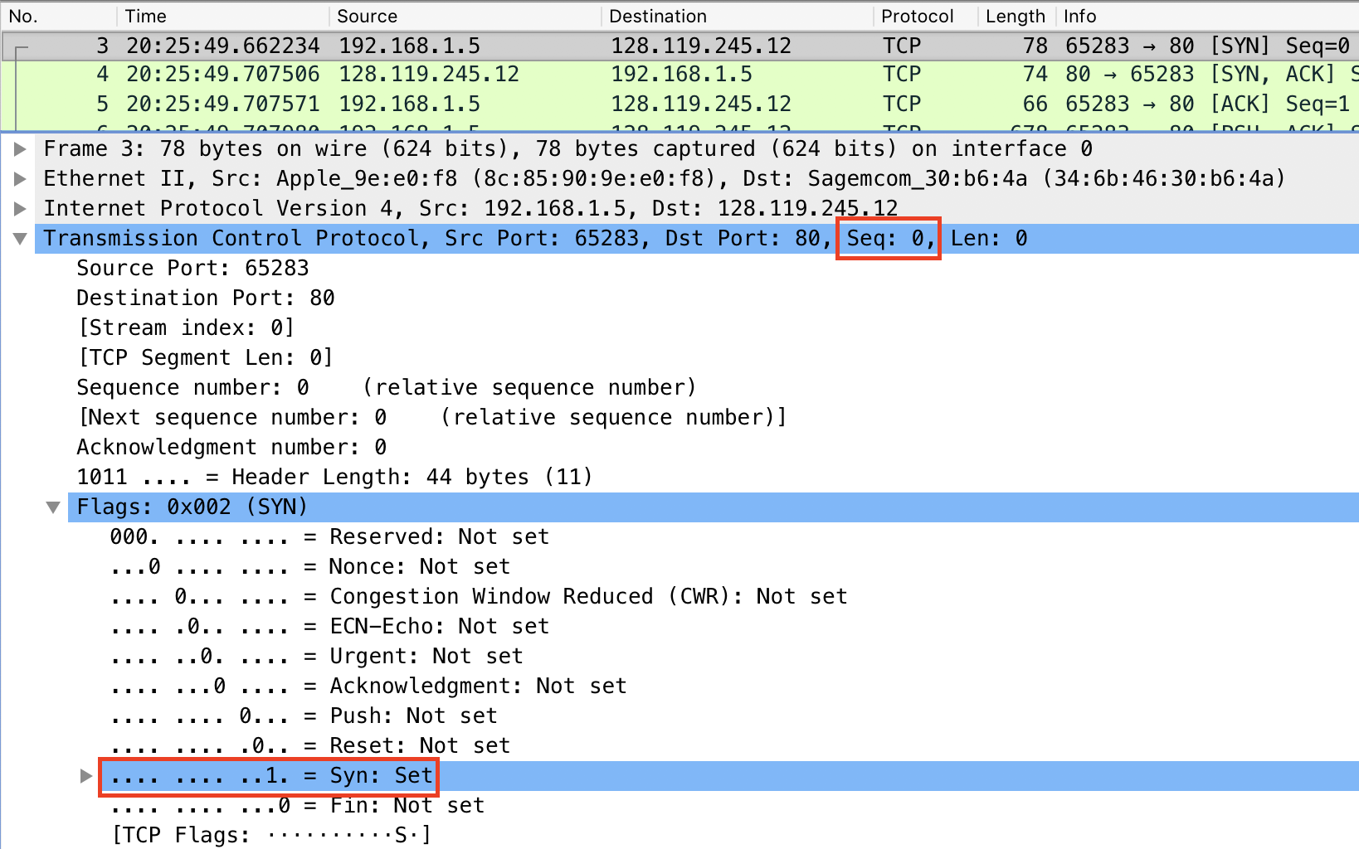

1. What is the sequence number of the SYNACK segment sent by gaia.cs.umass.edu to the client computer in reply to the SYN? What is the value of the Acknowledgement field in the SYNACK segment? How did gaia.cs.umass.edu determine that value? What is it in the segment that identifies the segment as a SYNACK segment?

The sequence number is 0 because we are acknowledging the 0-th segment in the sequence.

The acknowledgement field is 1 because we add one to the initial sequence number of the SYN (which, of course, was 0).

Both the acknowledgement and syn flags are set, so we know we have a SYNACK segment.

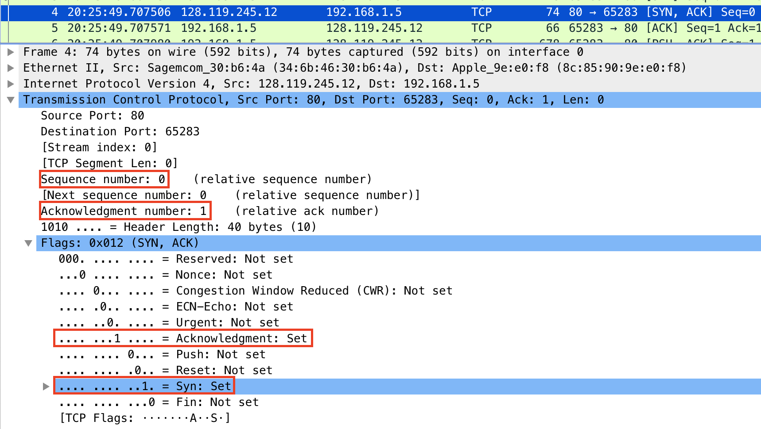

1. What is the sequence number of the TCP segment containing the HTTP POST command? Note that in order to find the POST command, you’ll need to dig into the packet content field at the bottom of the Wireshark window, looking for a segment with a “POST” within its DATA field.

The TCP segment with the HTTP POST command has a sequence number of 1. It’s segment number 6 overall.

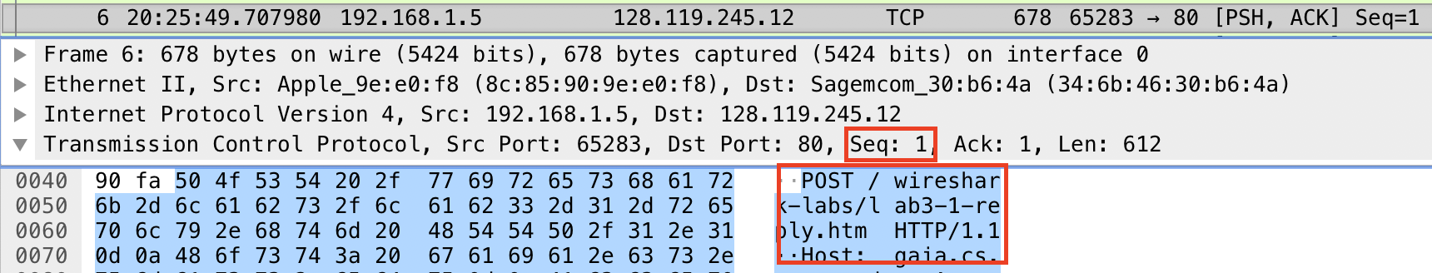

1. Consider the TCP segment containing the HTTP POST as the first segment in the TCP connection. What are the sequence numbers of the first six segments in the TCP connection (including the segment containing the HTTP POST)? At what time was each segment sent? When was the ACK for each segment received? Given the difference between when each TCP segment was sent, and when its acknowledgement was received, what is the RTT value for each of the six segments? What is the *EstimatedRTT* value (see Section 3.5.3, page 242 in text) after the receipt of each ACK? Assume that the value of the *EstimatedRTT* is equal to the measured RTT for the first segment, and then is computed using the *EstimatedRTT* equation on page 242 for all subsequent segments.

*Note:* Wireshark has a nice feature that allows you to plot the RTT for each of the TCP segments sent. Select a TCP segment in the “listing of captured packets” window that is being sent from the client to the gaia.cs.umass.edu server. Then select: *Statistics->TCP Stream Graph->Round Trip Time Graph.*

The first six segments have the following segment and sequence numbers, time of transmission, and time of acknowledgement (assume all times are in seconds):

|  |  |  |  |  |  |
| --- | --- | --- | --- | --- | --- |
| **Segment** | **Segment Number** | **Sequence Number** | **Time Sent** | **ACK Segment Number** | **Time Acknowledged** |
| 1 | 6 | 1 | 20:25:49.707980 | 10 | 20:25:49.756020 |
| 2 | 7 | 613 | 20:25:49.708190 | 11 | 20:25:49.756027 |
| 3 | 8 | 748 | 20:25:49.708373 | 12 | 20:25:49.756029 |
| 4 | 9 | 2196 | 20:25:49.708374 | 18 | 20:25:49.809658 |
| 5 | 13 | 3644 | 20:25:49.756133 | 19 | 20:25:49.809662 |
| 6 | 14 | 5092 | 20:25:49.756133 | 26 | 20:25:49.817146 |

The first six segments have the following round-trip and estimated round-trip times (times are in seconds):

|  |  |  |
| --- | --- | --- |
| **Segment** | **Round-Trip Time** | **Estimated RTT** |
| 1 | 0.048040 | 0.048040 |
| 2 | 0.047837 | 0.048015 |
| 3 | 0.047656 | 0.047970 |
| 4 | 0.101285 | 0.054634 |
| 5 | 0.053529 | 0.054496 |
| 6 | 0.061013 | 0.060854 |

It’s difficult to show all of this information in a limited number of screenshots, but I’ve done my best below.



1. What is the length of each of the first six TCP segments?

The first two segments have lengths of 612 and 135 bytes, respectively. The next four segments each have a length of 1448 bytes.

Here are the six segments with all necessary information:

|  |  |  |  |  |  |
| --- | --- | --- | --- | --- | --- |
| **Sequence Number** | **Time Sent** | **Time Acknowledged** | **Round-Trip Time** | **Estimated RTT** | **Length** |
| 1 | 20:25:49.707980 | 20:25:49.756020 | 0.048040 | 0.048040 | 612 |
| 613 | 20:25:49.708190 | 20:25:49.756027 | 0.047837 | 0.048015 | 135 |
| 748 | 20:25:49.708373 | 20:25:49.756029 | 0.047656 | 0.047970 | 1448 |
| 2196 | 20:25:49.708374 | 20:25:49.809658 | 0.101285 | 0.054634 | 1448 |
| 3644 | 20:25:49.756133 | 20:25:49.809662 | 0.053529 | 0.054496 | 1448 |
| 5092 | 20:25:49.756133 | 20:25:49.817146 | 0.061013 | 0.060854 | 1448 |

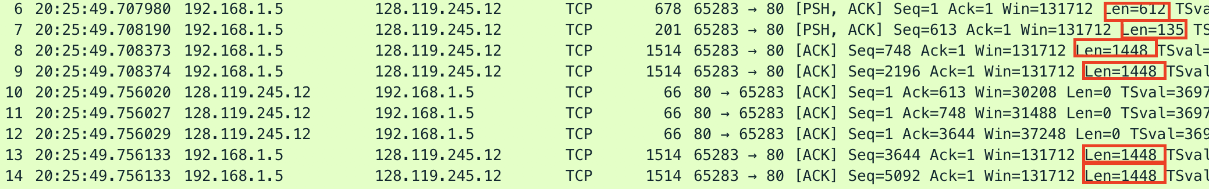

1. What is the minimum amount of available buffer space advertised at the receiver for the entire trace? Does the lack of receiver buffer space ever throttle the sender?

We can see in the first acknowledgement from the server that the minimum window size is 28960 bytes. We can see in the trace that the sender is never throttled by a lack of receiver buffer space.

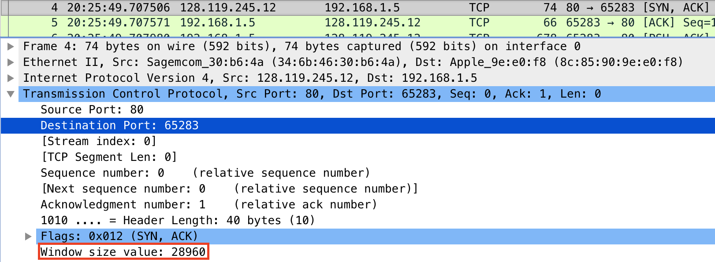

1. Are there any retransmitted segments in the trace file? What did you check for (in the trace) in order to answer this question?

We can see in the time sequence graph below that the sequence numbers increase monotonically at all times. This indicates that no segments were retransmitted. If we did witness retransmitted segments, we would see on the graph a sequence number that is less than those transmitted before it (in time).

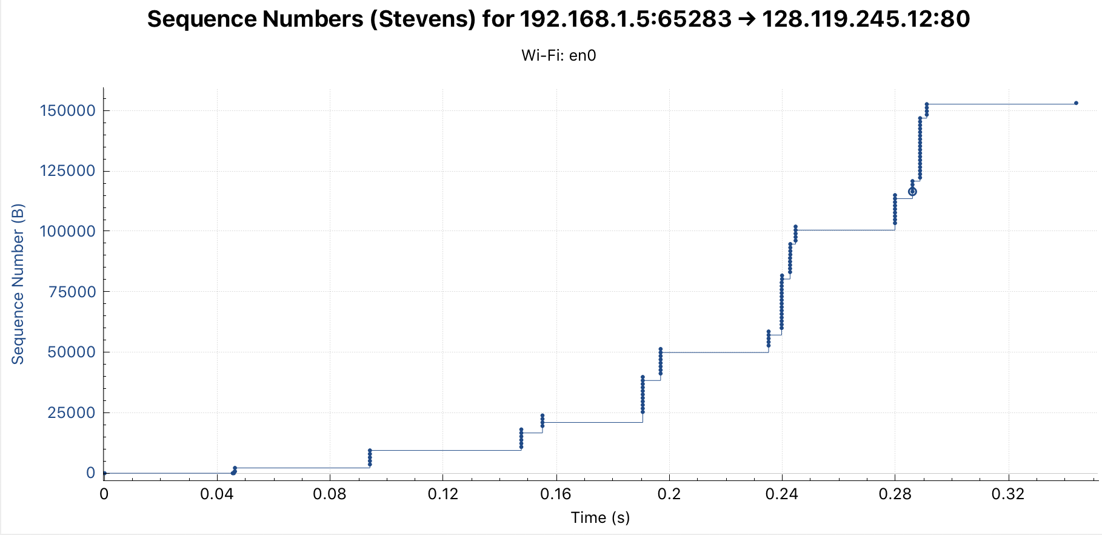

1. How much data does the receiver typically acknowledge in an ACK? Can you identify cases where the receiver is ACKing every other received segment (see Table 3.2 on page 250 in the text).

I’ve shown the first ten acknowledgements in the table below. In half of the cases, we see that the receiver acknowledges a multiple of 2896 bytes.

|  |  |  |  |
| --- | --- | --- | --- |
| **Acknowledgement** | **Segment** | **Sequence Number** | **Acknowledged Data (bytes)** |
| 1 | 10 | 613 | 613 |
| 2 | 11 | 748 | 135 |
| 3 | 12 | 3644 | 2896 |
| 4 | 18 | 6540 | 2896 |
| 5 | 19 | 7988 | 1448 |
| 6 | 26 | 10844 | 2896 |
| 7 | 31 | 13780 | 2896 |
| 8 | 32 | 15228 | 1448 |
| 9 | 33 | 19572 | 4344 |
| 10 | 45 | 22468 | 2896 |

As shown in the table above and in the screenshot immediately below, segment 18 acknowledges more than one received segment. The previous unacknowledged segments are each 1448 bytes, but segment 18 acknowledges 2896 bytes and, because $2*1448=2896$, we know that segment 18 acknowledged two segments.

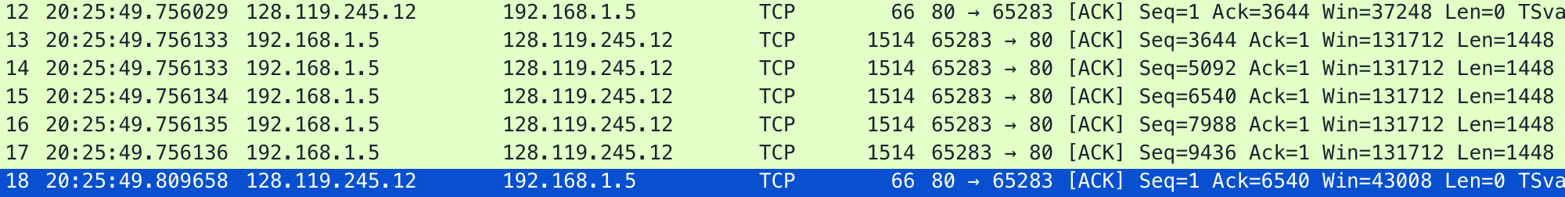

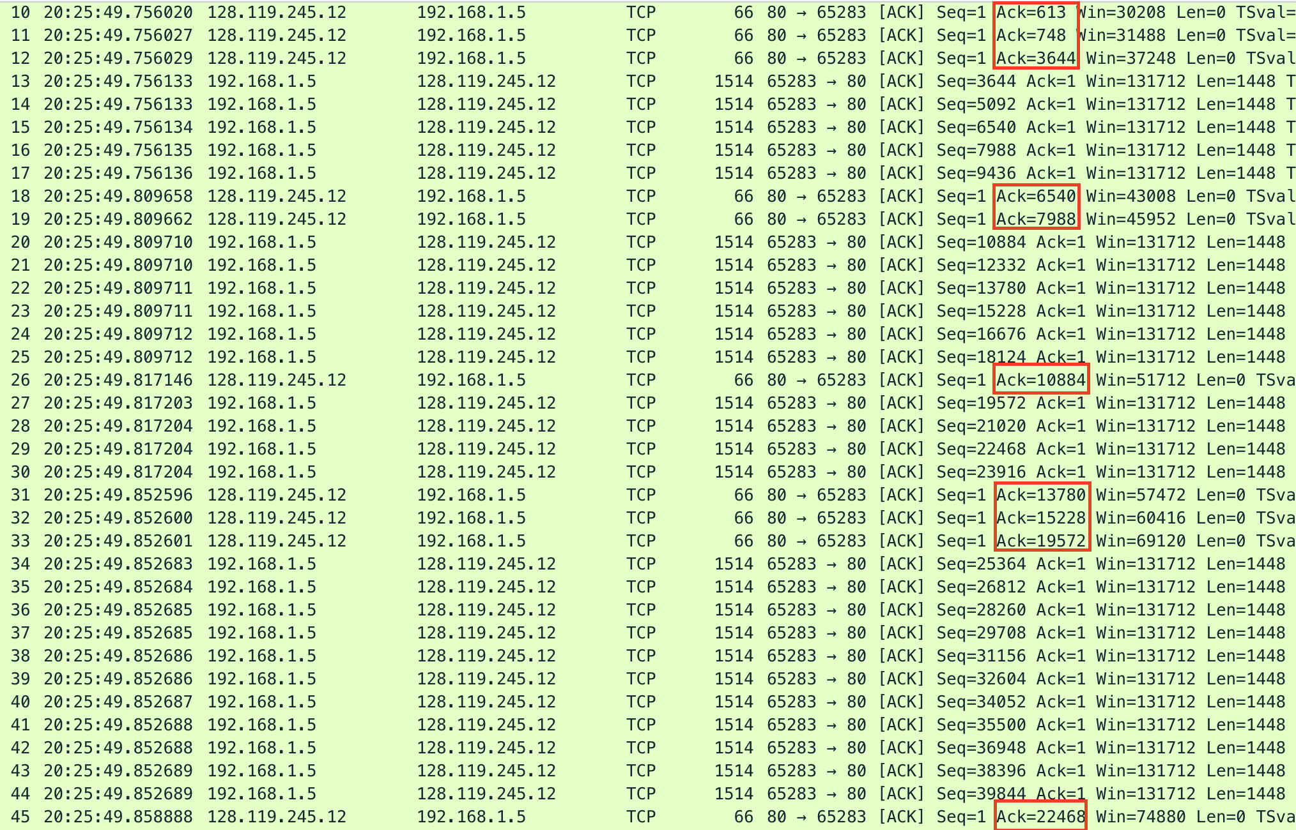

1. What is the throughput (bytes transferred per unit time) for the TCP connection? Explain how you calculated this value.

The size of alice.txt is 152478 bytes, and the upload of alice.txt required $20:25:49.707980-20:25:50.006017=0.298037 seconds$.

This indicates that the throughput is .

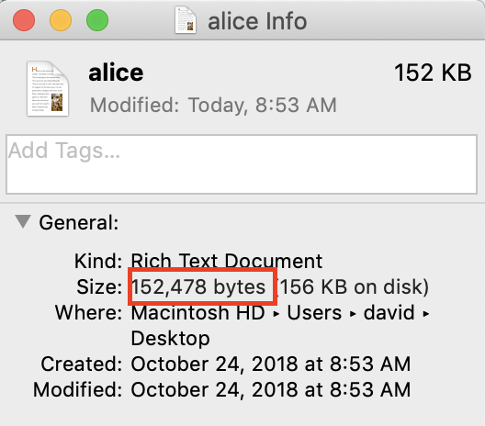





1. Use the *Time-Sequence-Graph(Stevens*) plotting tool to view the sequence number versus time plot of segments being sent from the client to the gaia.cs.umass.edu server. Can you identify where TCP’s slowstart phase begins and ends, and where congestion avoidance takes over? Comment on ways in which the measured data differs from the idealized behavior of TCP that we’ve studied in the text.

We can see in the plot that the slowstart phase starts immediately and ends within the first 0.3 seconds. After that, congestion avoidance takes over.

The measured data is different from the idealized behavior in that it doesn’t grow linearly. Instead, it transmits data in batches of six segments for almost the entire transmission period. We know the receiver’s advertised window is bigger than that, so it seems the transmission is limited by the HTTP server or something similar. Regardless, the connection is not utilizing very much of the available window size.

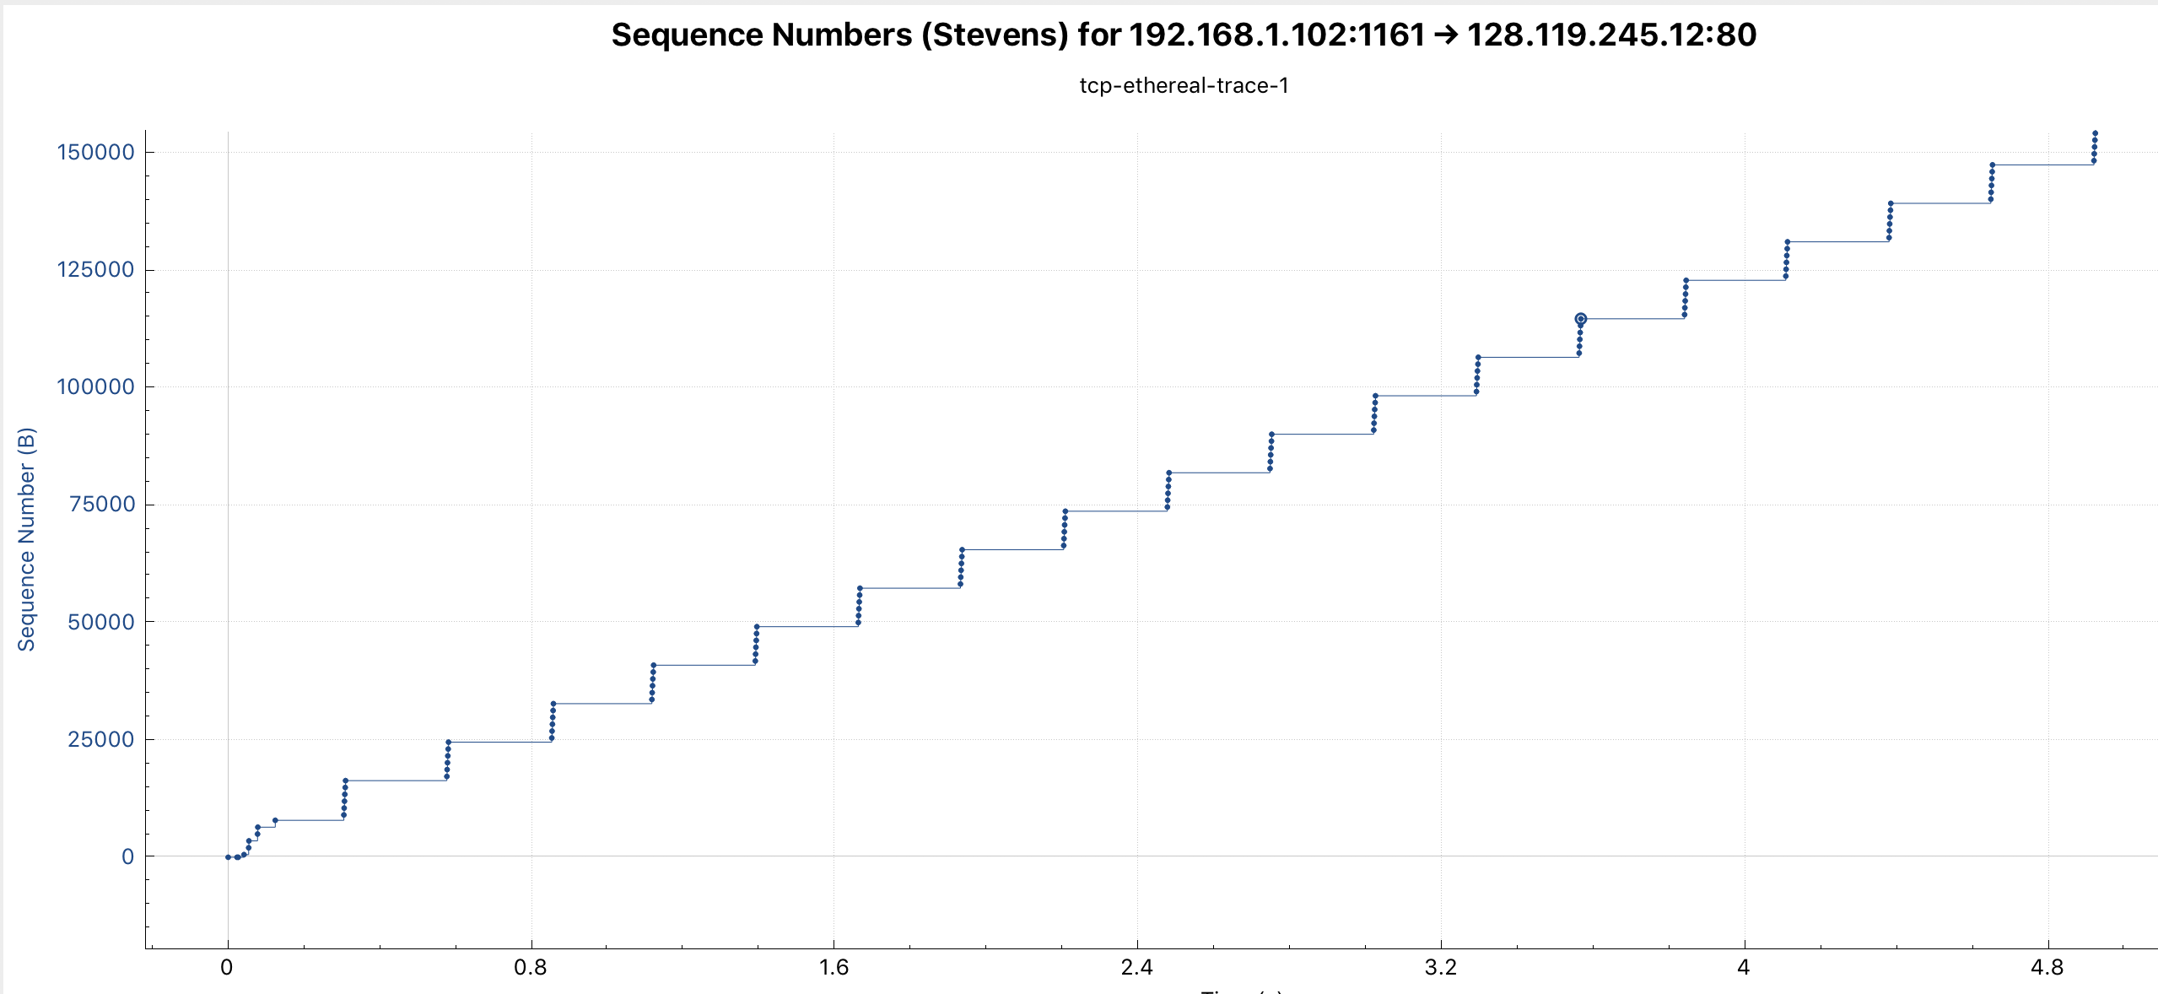

1. Answer each of two questions above for the trace that you have gathered when you transferred a file from your computer to gaia.cs.umass.edu.

The slowstart phase again starts immediately, but the end of the phase is much harder to pinpoint than in the previous graph. It seems that it ends between 0.20 and 0.26 seconds, but I can’t identify exactly where. Congestion avoidance again takes over at that point.

This graph is different from the idealized behavior in that it still only uses a fraction of the available window size.

